Project Report on

E-comShop (E-commerce website)

**Major Project**

Integrated Master of Computer Application (IMCA)

By

**Yuvraj Patidar**

**0810CA18DD40**

**10th Semester**

Under the supervision of

**Prof. Tarunesh Verma**



**IPS Academy Indore**

**School of Computers**

**RAJIV GANDHI PROUDYOGIKI VISHWAVIDHYALAYA, BHOPAL**

**2022**

**CERTIFICATE**

The is to certify that **Yuvraj Patidar,** **0810CA18DD40,** of Integrated Master of Computer Application (IMCA**), SOC IPS ACADEMY** has successfully completed his **10th semester** minor project entitled

**E-comShop website**

**(E-commerce website)**, under the guidance of

**Prof. Tarunesh Verma** as a part of fulfilment of academic curriculum.

**External Examiner**

**Date:**

**Internal Examiner**

**Date:**

Director

**IPS Academy Indore**

**School of Computers**

**Acknowledgement**

The satisfaction that accompanies that the successful completion of any task would be incomplete without the mention of people whose ceaseless corporation made it possible whose constant guidance and encouragement crown all efforts with success.

We are grateful to our guide **Prof. Tarunesh Verma** for the guidance, inspiration and constructive suggestions that helpful us in preparation of this project.

We also thank who have helped in successful completion of the project.

Date:

Place: **IPS Academy Indore**

**Yuvraj Patidar**

**0810CA18DD40**

**IMCA 10th Semester**

**TABLE OF CONTENTS**

|  |  |  |
| --- | --- | --- |
| **Chapter No.** | **Title** |  |
|  | Certificate |  |
|  | Acknowledgement |  |
| 1  1.1  1.2  1.3  1.4  1.5  1.6 | **Introduction**  Introduction  Problem definition  Motivation  Objective  Proposed solution  Platform Specification |  |
| 2  2.1  2.2  2.3 | **Background and related work**  Existing system  Proposed system  Scope of Proposed system |  |
| 3  3.1  3.2  3.3  3.4 | **System analysis and design**  Feasibility study  Non-functional requirement  Functional requirement  Design |  |
| 4  4.1  4.2  4.3 | **Implementation**  History and feature  Application  Screenshots with Detail |  |
| 5  5.1  5.2 | **Testing**  Test steps  Test case |  |
| 6  6.1  6.2 | **Database description**  List of tables  Structure of table |  |
| 7  7.1  7.2  7.3  7.4 | **Conclusion and Discussion**  Conclusion and discussion  Future Scope of the Project  Snapshot  Bibliography |  |
|  |  |  |

1. **Introduction**

**1.1 Introduction: -**

The introduction of an e-commerce website for a report typically provides an overview of the purpose of the report and the scope of the e-commerce website project.

An e-commerce website is an online platform that allows businesses to sell products and services directly to customers. With the increasing trend of online shopping, having a robust and user-friendly e-commerce website has become a necessity for businesses of all sizes. An e-commerce website project typically involves designing and developing a website that includes features such as product catalogs, shopping carts, checkout systems, and payment gateways.

The introduction of an e-commerce website report should provide a brief overview of the project's objectives and scope. It should also outline the key features of the e-commerce website and the benefits it will provide to the business, such as increased revenue, improved customer experience, and expanded reach.

Additionally, the introduction should provide an overview of the methodology used in developing the e-commerce website, including the hardware and software requirements, the development process, and the testing and deployment process. Finally, the introduction should set the stage for the report, providing the reader with a clear understanding of what to expect in the subsequent sections.

* 1. **Problem Definition: -**

The problem definition of e-commerce is the challenge faced by businesses in selling their products and services online. Some of the primary problems that businesses face in e-commerce include:

1. Customer Acquisition: Acquiring new customers can be a significant challenge for businesses operating in e-commerce. With the increasing competition and a plethora of options available for customers, businesses need to have a robust marketing strategy to attract and retain customers.

2. Website Performance: Slow-loading websites or poor website design can result in a poor customer experience, leading to a high bounce rate and low conversion rates. Ensuring website performance, scalability, and usability is crucial to the success of an e-commerce website.

3. Payment Security: Ensuring the security of online transactions is a significant concern for both businesses and customers. Implementing secure payment gateways, adhering to PCI compliance standards, and adopting best practices for data encryption and storage can help mitigate this problem.

4. Supply Chain Management: Managing inventory, logistics, and supply chain can be a significant challenge for businesses operating in e-commerce. Businesses need to have an efficient supply chain management system in place to ensure timely delivery and optimal inventory levels.

5. Competition: With the increasing number of businesses operating in e-commerce, the competition is intense, making it challenging for businesses to stand out and gain a competitive edge.

Addressing these challenges requires businesses to develop a comprehensive strategy that considers the needs of customers, the competitive landscape, and the technical requirements of an e-commerce website.

* 1. **Motivation: -**

The motivation behind creating an e-commerce website is to enable businesses to expand their reach and increase their revenue by tapping into the growing trend of online shopping. The rise of the internet and mobile technologies has transformed the way customers interact with businesses, creating new opportunities for businesses to engage with their customers.

An e-commerce website provides businesses with a platform to sell their products and services directly to customers, regardless of their location. This eliminates the need for physical stores, reducing overhead costs and allowing businesses to offer competitive pricing.

Moreover, an e-commerce website provides customers with convenience, flexibility, and an improved shopping experience. Customers can browse products, compare prices, and make purchases at any time, from anywhere, using their desktop or mobile devices. This has led to a significant increase in online sales, making e-commerce a critical channel for businesses to reach their customers.

In addition to expanding reach and increasing revenue, e-commerce websites offer several other benefits, including:

1. Improved customer insights: E-commerce websites allow businesses to gather valuable customer data, such as purchase history, browsing behavior, and demographics, which can be used to personalize the shopping experience and improve customer retention.

2. Cost-effective marketing: Digital marketing channels, such as social media and email marketing, can be used to promote products and services, without the high costs associated with traditional marketing.

3. Greater customer engagement: E-commerce websites provide businesses with an opportunity to engage with their customers through various channels, such as chatbots, social media, and email, creating a loyal customer base.

Overall, the motivation behind an e-commerce website is to enable businesses to leverage the power of the internet and mobile technologies to reach a broader audience, increase revenue, and provide an exceptional shopping experience to their customers.

* 1. **Objective: -**

The objective of an e-commerce website is to enable businesses to sell products and services directly to customers through an online platform. The primary objectives of an e-commerce website project include:

1. To expand the reach of the business: E-commerce websites provide businesses with a platform to reach a global audience, regardless of their location, expanding their reach beyond the local market.

2. To increase revenue: E-commerce websites can help businesses increase their revenue by offering a convenient and user-friendly platform for customers to purchase products and services.

3. To provide a better shopping experience: E-commerce websites provide customers with a convenient and personalized shopping experience, making it easy for them to browse products, compare prices, and make purchases.

4. To improve customer engagement: E-commerce websites provide businesses with an opportunity to engage with their customers through various channels, such as chatbots, social media, and email, creating a loyal customer base.

5. To gather valuable customer insights: E-commerce websites allow businesses to gather valuable customer data, such as purchase history, browsing behavior, and demographics, which can be used to personalize the shopping experience and improve customer retention.

6. To streamline business operations: E-commerce websites can help businesses streamline their operations by automating tasks such as inventory management, order fulfillment, and shipping.

Overall, the objective of an e-commerce website is to provide businesses with a platform to expand their reach, increase revenue, and provide an exceptional shopping experience to their customers.

* 1. **Proposed solution: -**

There are several key components that are essential for a successful ecommerce website. Here are some proposed solutions:

1. User-friendly interface: The website should have a clean and intuitive design that is easy to navigate. It should be easy for users to find what they are looking for and to complete transactions. Consider using clear and concise product descriptions, high-quality images, and user-friendly shopping cart and checkout processes.

2. Secure payment processing: One of the biggest concerns for online shoppers is security. To build trust with customers, it is important to use a secure payment gateway and to prominently display security badges or trust seals on the website.

3. Mobile optimization: With more people shopping on their smartphones and tablets, it is essential that your ecommerce website is optimized for mobile devices. The website should be responsive and easy to use on smaller screens.

4. Search engine optimization (SEO): SEO is the process of optimizing your website for search engines so that it ranks higher in search results. This can help drive more traffic to your website and increase sales. Consider using relevant keywords in product descriptions and titles, optimizing meta tags and descriptions, and building high-quality backlinks to your website.

5. Customer service: Providing excellent customer service is essential for building a loyal customer base. Consider offering multiple channels for customer support, such as email, phone, and live chat. Respond to customer inquiries promptly and professionally, and be transparent about shipping times and return policies.

6. Analytics and reporting: It is important to track and analyze website traffic, sales, and other key metrics to identify areas for improvement and to make data-driven decisions. Consider using tools such as Google Analytics or other ecommerce-specific analytics platforms to track website performance and customer behavior.

By focusing on these key components, you can create a successful ecommerce website that attracts and retains customers and drives sales.

* 1. **Platform Specification: -**

The current time had a lot of challenges that are overcome by this:

**Economic:** The proposed system is economic as there will not be any person required of money to registered as themselves in the website.

**Real-Time Observation:** This can be lead to help the customers or user to create printing material for them with a little knowledge of designing by just filling some forms.

**1.6.1 Hardware requirements: -**

1. Processor: A multi-core processor with at least 2 GHz clock speed is recommended.

2. Memory: A minimum of 4 GB of RAM is recommended.

3. Storage: At least 50 GB of storage space is recommended for hosting the website and storing data.

4. Bandwidth: Sufficient bandwidth is required to ensure fast website performance, especially during high traffic periods.

**1.6.2 Software requirements:**

1. Operating system: Django is cross-platform and can run on Windows, Mac, or Linux. However, it is recommended to use a Linux-based operating system, such as Ubuntu or CentOS, for better performance and security.

2. Python: Django is built on Python, so Python 3.x is required to run Django.

3. Database: Django supports several databases, including PostgreSQL, MySQL, SQLite, and Oracle. It is recommended to use PostgreSQL or MySQL for production environments.

4. Web server: Django includes a lightweight web server for development, but a more robust web server such as Apache or Nginx is recommended for production environments.

5. Development environment: A code editor such as Visual Studio Code, PyCharm, or Sublime Text is recommended for development.

By meeting these hardware and software requirements, you can build a reliable and high-performance ecommerce website using Django.

1. **Background and related work: -**

**2.1** **Existing System: -**

The computerization of this system would avoid the wrong interpretation and bad calculation of data. The system helps the user to see any documents, source code, tasks, activities, team information with details at the click of a button. The record data is maintained and backed up such a way that data is not loss. The speed of the system could also increase.

They are done only manually but in proposed system we have to computerize the test using this application.

• Lack of security data.

• Time consuming.

• More man powers.

• No direct role for the higher officials.

After understanding the existing system and understanding the need for developing a system different people involved in the related activities have been consulted.

* 1. **Proposed System: -**

The proposed system of an e-commerce website typically includes the following components:

1. Front-end interface: This is the visible part of the website that customers interact with, including the user interface, product pages, shopping cart, and checkout process. It's essential to design the front-end interface to be visually appealing, intuitive, and easy to use.

2. Back-end database: The back-end database stores all the website's data, including product information, customer data, and order history. It's crucial to design the database to be scalable, secure, and easily maintainable.

3. Content management system: A content management system (CMS) allows website administrators to manage and update website content, including product descriptions, images, and pricing information. A robust CMS can simplify content management and improve website efficiency.

4. Payment gateway: A payment gateway enables customers to make secure online payments using various payment methods, such as credit cards, debit cards, and online payment systems. It's important to select a reliable and secure payment gateway to protect customer data and transactions.

5. Order management system: An order management system (OMS) manages the order processing, fulfilment, and shipment tracking. A robust OMS can streamline order management and improve customer satisfaction.

6. Customer relationship management: A customer relationship management (CRM) system manages customer data, including their personal information, purchase history, and contact details. A robust CRM can improve customer engagement and retention.

7. Analytics and reporting: Analytics and reporting tools provide insights into website traffic, customer behaviour, and sales data. Robust analytics and reporting system can help website administrators identify areas for improvement and optimize the website's performance.

By integrating these components, businesses can create a robust and efficient e-commerce website that provides a seamless and engaging shopping experience for customers while streamlining backend processes and improving business efficiency.

* 1. **Scope of project: -**

The scope of an ecommerce website can vary depending on the type of business, products or services being offered, and the target audience. Here are some common elements that are typically included in the scope of an ecommerce website:

1. Product Catalog: The ecommerce website should have a product catalog that showcases the products or services being offered. This should include product images, descriptions, prices, and any other relevant information.

2. Shopping Cart: A shopping cart system should be implemented so that customers can add products to their cart and proceed to checkout.

3. Payment Processing: An ecommerce website should have a payment processing system that allows customers to securely pay for their purchases online. This should include integration with a payment gateway like PayPal or Stripe.

4. Order Management: The ecommerce website should have an order management system that allows the business to track and manage customer orders. This should include the ability to view order history, manage shipping and returns, and track inventory.

5. User Accounts: The ecommerce website should allow users to create accounts and manage their personal information, such as shipping addresses and payment methods.

6. Customer Support: An ecommerce website should provide customer support options, such as email, phone, or live chat, to help customers with any questions or issues they may have.

7. Marketing and Analytics: An ecommerce website should include marketing and analytics tools to help businesses track website traffic, customer behavior, and sales data. This should include integration with tools like Google Analytics, social media platforms, and email marketing services.

By including these elements in the scope of an ecommerce website, businesses can create a comprehensive online presence that attracts customers and drives sales.

# **System analysis and design**

## Feasibility study

A feasibility study is an analysis of how successfully a system can be implemented, accounting for factors that affect it such as economic, technical and operational factors to determine its potential positive and negative outcomes before investing a considerable amount of time and money into it.

## Technical feasibility

The main technologies associated with it are

|  |  |
| --- | --- |
| Software | Windows 10 |
| Languages | HTML, CSS, JS, JQuery, Python Framework Django, Bootstrap |
| Hardware | i3 processor based computer, Monitor, Internet Connection, RAM 512 MB, ROM 50GB min. |

Each of the technologies are freely (software’s) and easily (hardware’s) available and the technical skills required are manageable.

From this it’s clear that the project **Ecommerce website “E-comshop”** is technically feasible.

## 3.1.2 Economical feasibility

Time limitations of the project development and these technologies are synchronized. The system will follow the freeware software standards no cost will be charge from the potential customers.

## 3.1.3 Operational feasibility

The main motive of this system is to reduce the manual efforts of user automating their task with the help of this concept. The system is able to do that accurately and efficiently making the system operationally feasible.

## 3.2 Non-Functional requirement

## **Performance Requirements**

Performance requirements define acceptable response times for system functionality. Although the system is developed suiting for the least system performances, the performance of the system will highly depend on the performance of the hardware and software components of the installing computer. When consider about the timing relationships of the system the load time for user interface screens shall take no longer than two seconds. It makes fast access to system functions. The log in information shall be verified within seconds causes efficiency of the system, returning query results within live seconds makes search function more accurate.

## **Software Quality Attributes**

* Availability: The system shall be available anytime.
* Correctness: - extent to which program satisfies specifications, fulfils user's mission objectives
* Efficiency: - How much less number of resources and time are required to achieve a particular task through the system.
* Flexibility: - Ability to add new features to the system and handle them conveniently.
* Integrity: How the system would insecure the information in the system and how it avoids the data losses. Referential integrity in database tables and interfaces
* Maintainability: How easy is to keep the system as it is and correct defects with making changes.
* Reliability: - Specify the factors required to establish the required reliability of the software time of delivery. Mean time between failures and mean time to recovery
* Reusability: - It is the ability to use the available components of the system in other system systems as well.
* Testability: Effort needed to test to ensure performs as intended
* Usability: How easily a person can he taken the benefits of the system and the user friendliness.
* Robustness: Strength of the system to handle system functions accurately and maintain the database without facing to unexpected failures
* Maintainability: Design, coding standards must be adhered to exclusions created

**3.3 Functional requirement**

|  |  |
| --- | --- |
| Function 1 | **Add Product** |
| Input | Product name , product price prodeuct discrption |
| Output | Database Record , Database successfully updated |
| Processing | Validate the given details and record the information in to the database. |

|  |  |
| --- | --- |
| Function 2 | **Contact Us page** |
| Input | User name , email, mobile and feedback |
| Output | Database Record , Database successfully updated |
| Processing | Validate the given details and record the information in to the database. |

|  |  |
| --- | --- |
| Function 3 | **Product tracker page** |
| Input | Product id and user email |
| Output | Database Record , Database successfully updated |
| Processing | Validate the given details and record the information in to the database. |

|  |  |
| --- | --- |
| Function 4 | **Add to cart/place order Page** |
| Input | Order name and price, Name, email ,Mobile No., Address, |
| Output | Database Record , Database successfully updated |
| Processing | Validate the given details and record the information in to the database. |

* 1. **Design: -**

It has client server architecture. It is made with Apache 2.4, and use and the event handlers and codes are done in Microsoft Visual Code Studio. This facilitates easy interface design along with coding which is reflected as any changes are made in design.

 It consists of many tables, one to include user’s personal information and other to maintain user’s files and projects. The input to database for personal information is given by the user in page. The files saved in editor are stored in the files table in database. The output is in the form of list of files made by the user so that he may choose to edit or delete files.

**UML Approach**

**UML Diagram**

A diagram is the graphical presentation of a set of elements, most often rendered as a connected graph of vertices and arcs. you draw diagram to visualize a system from different perspective, so a diagram is a projection into a system. For all but most trivial systems, a diagram represents an elided view of the elements that make up a system. The same element may appear in all diagrams, only a few diagrams, or in no diagrams at all. In theory, a diagram may contain any combination of things and relationships. In practice, however, a small number of common combinations arise, which are consistent with the five most useful views that comprise the architecture of a software- intensive system. For this reason, the UML includes nine such diagrams:

1. Use case diagram
2. Use Case Scenarios
3. Activity diagram

## 1. Use case diagram:

A use case diagram in the Unified Modeling Language(UML) is a type of behavioral diagram defined by and created from a use-case analysis. Its purpose is to present a graphical overview of the functionality provided by a system in terms of actors, their goals (represented as use cases), and any dependencies between those use cases.

Use case diagrams are formally included in two modeling languages defined by the OMG: the unified modeling language(UML) and the systems modeling language(sysML)

## Use case diagram of our project:

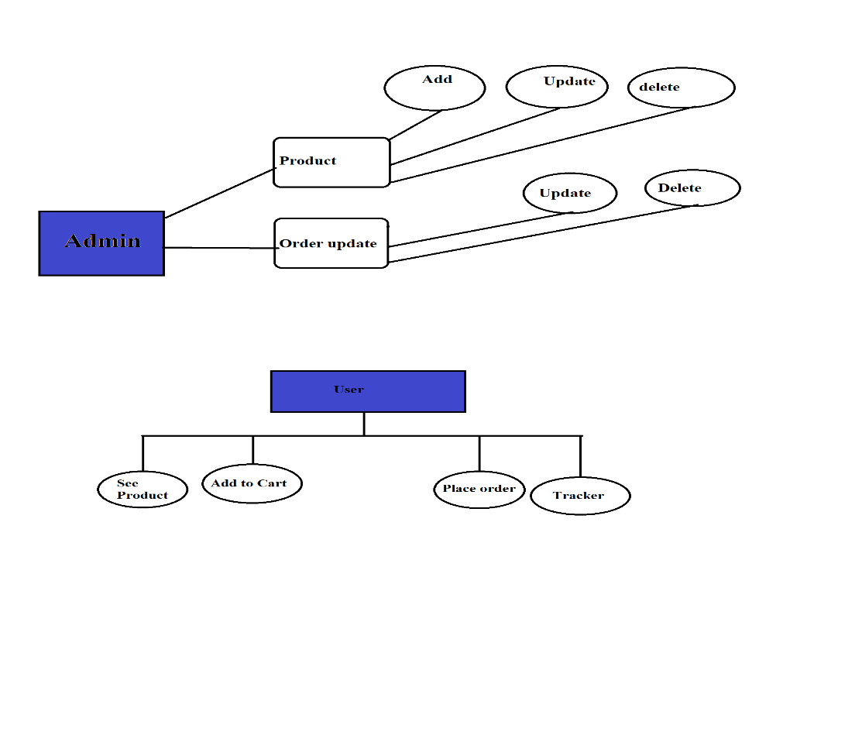

## Use case scenario:

|  |  |  |
| --- | --- | --- |
| User case Name | Add the product | |
| Goal | Taking information displayed on ID Card | |
| Primary Actor | Admin | |
| Secondary Actor |  | |
| Precondition | Log in to the system | |
| Post condition |  | |
| Main flow | Step | Action |
| 1 | User selects “Add product” button |
| 2 | System prompt to fill out Basic details Required for product |
| 3 | System validates details |
| 4 | Update database |
| 5 | Display “Successful Message”. |
| Extension | 1 | If details incorrect. Display message “Unsuccessful”. |

|  |  |  |
| --- | --- | --- |
| User case Name | Order update | |
| Goal | Taking information displayed on Certificate | |
| Primary Actor | Admin | |
| Secondary Actor |  | |
| Precondition | Log in to the system | |
| Post condition |  | |
| Main flow | Step | Action |
| 1 | User selects “order update” button |
| 2 | System prompt to fill out Basic details of order updation |
| 3 | System validates details |
| 4 | Update database |
| 5 | Display “Successful Message”. |
| Extension | 1 | If details incorrect. Display message “Unsuccessful”. |

|  |  |  |
| --- | --- | --- |
| User case Name | Place order | |
| Goal | Taking information displayed on about page | |
| Primary Actor | User | |
| Secondary Actor | User | |
| Precondition | Log in to the system | |
| Post condition |  | |
| Main flow | Step | Action |
| 1 | User selects “place order” button |
| 2 | System prompt to fill out Basic details of customer to place their order |
| 3 | System validates details |
| 4 | Update database |
| 5 | Display “Successful Message”. |
| Extension | 1 | If details incorrect. Display message “Unsuccessful”. |

|  |  |  |
| --- | --- | --- |
| User case Name | Order Tracker | |
| Goal | Taking information displayed on about page | |
| Primary Actor | User | |
| Secondary Actor | User | |
| Precondition | Log in to the system | |
| Post condition |  | |
| Main flow | Step | Action |
| 1 | Client selects “track order” button |
| 2 | System prompt to fill order id and customer email to tracker the order |
| 3 | System validates details |
| 4 | Update database |
| 5 | Display “Successful Message”. |
| Extension | 1 | If details incorrect. Display message “Unsuccessful”. |

## ACTIVITY DIAGRAM:

Add Product:

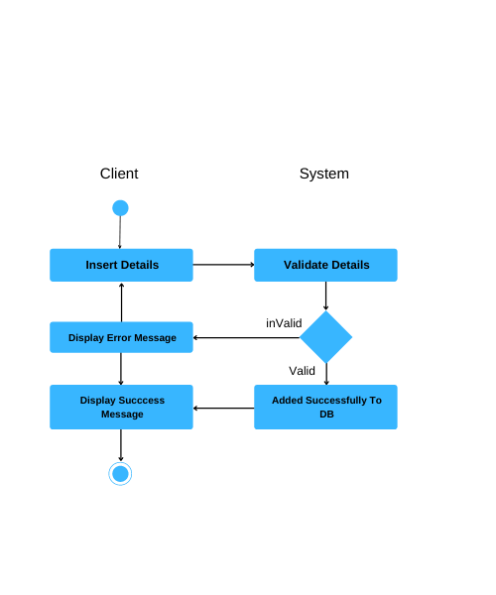

Order Update :



Place your order:



Track your product:



1. **Implementations: -**

**4.1 History and Features: -**

History:

In the early 1990s, the first ecommerce websites were launched, with companies like Amazon and eBay leading the way. These early ecommerce sites were simple, with basic product listings and limited payment options.

As internet technology improved, ecommerce sites became more sophisticated, offering a wider range of products and services, as well as more advanced payment and shipping options. Today, ecommerce websites are a crucial part of the global economy, with online sales projected to exceed $4.8 trillion by 2024.

Features:

1. Product Listings: Ecommerce websites typically feature a searchable product catalog that includes product images, descriptions, and pricing information.
2. Shopping Cart: An ecommerce website should have a shopping cart system that allows customers to add products to their cart and proceed to checkout.
3. Payment Processing: Ecommerce websites require a payment processing system that allows customers to securely pay for their purchases online. This should include integration with a payment gateway like PayPal or Stripe.
4. Order Management: An ecommerce website should have an order management system that allows the business to track and manage customer orders. This should include the ability to view order history, manage shipping and returns, and track inventory.
5. User Accounts: Ecommerce websites should allow users to create accounts and manage their personal information, such as shipping addresses and payment methods.
6. Customer Support: Ecommerce websites should provide customer support options, such as email, phone, or live chat, to help customers with any questions or issues they may have.
7. Marketing and Analytics: Ecommerce websites should include marketing and analytics tools to help businesses track website traffic, customer behavior, and sales data. This should include integration with tools like Google Analytics, social media platforms, and email marketing services.
8. Mobile Compatibility: With more and more customers accessing ecommerce sites on their mobile devices, it's important for ecommerce sites to be mobile-friendly and responsive.
9. Security: Ecommerce websites require a high level of security to protect customer data and prevent fraud. This should include SSL encryption, firewalls, and other security measures.

By incorporating these features, ecommerce websites can provide a seamless and secure shopping experience for customers, and help businesses reach a wider audience and increase sales.

**4.2 Application: -**

Ecommerce websites have numerous applications across different industries and business models. Here are some of the most common applications of ecommerce websites:

1. Retail: Retail businesses can use ecommerce websites to sell products online, expanding their customer base beyond their physical storefront. Ecommerce websites can also allow retail businesses to offer a wider range of products and services.

2. Wholesale: Wholesale businesses can use ecommerce websites to sell products in bulk to other businesses. Ecommerce websites can streamline the ordering process and provide real-time inventory updates.

3. Dropshipping: Ecommerce websites can be used for dropshipping, where a business partners with a supplier to sell their products without keeping them in stock. Ecommerce websites can automate the ordering and shipping process, making it easier for businesses to manage their operations.

4. Subscription services: Ecommerce websites can be used for subscription-based services, where customers pay a recurring fee for access to products or services. Ecommerce websites can automate the billing process and provide customers with a seamless experience.

5. Digital products: Ecommerce websites can be used to sell digital products, such as software, music, and ebooks. Ecommerce websites can automate the delivery process, making it easy for customers to access their purchases.

6. Services: Ecommerce websites can be used to sell services, such as web design, consulting, and tutoring. Ecommerce websites can automate the booking and payment process, making it easier for businesses to manage their operations.

* 1. **Screenshots with detail: -**

Screenshots are linked below.

Home page:

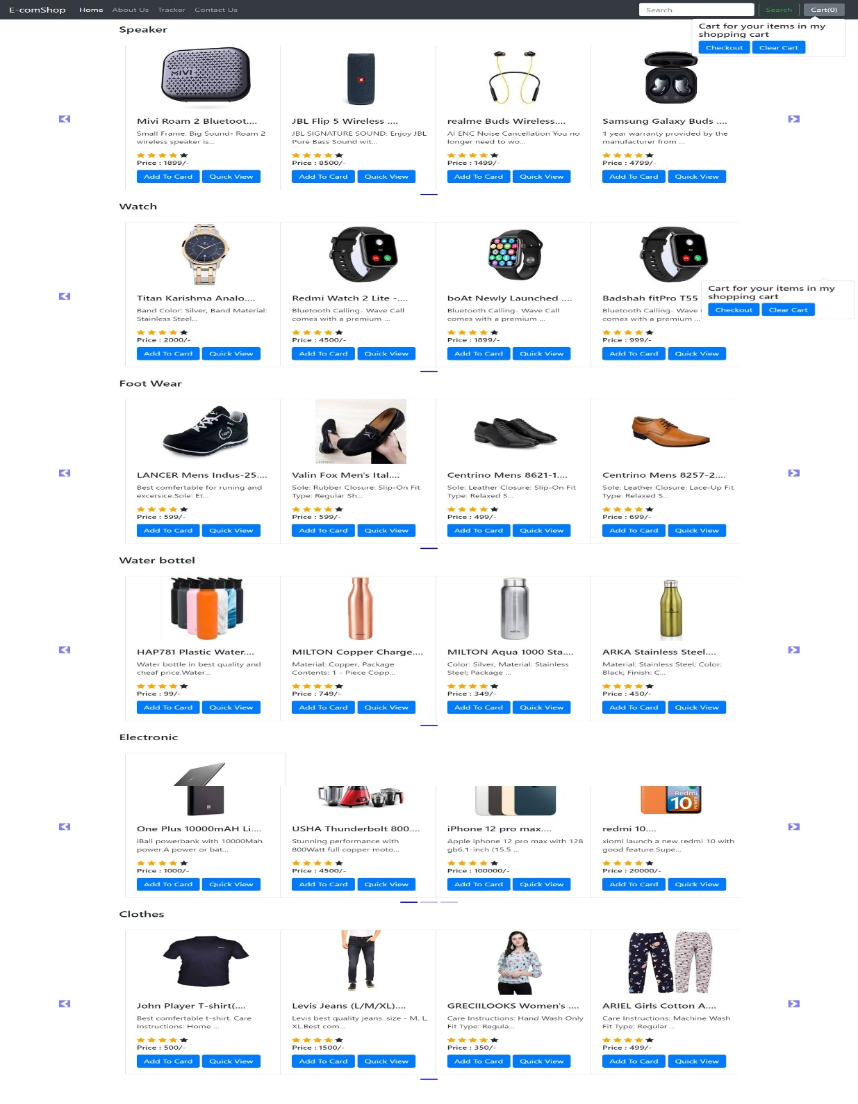

Product View page: -

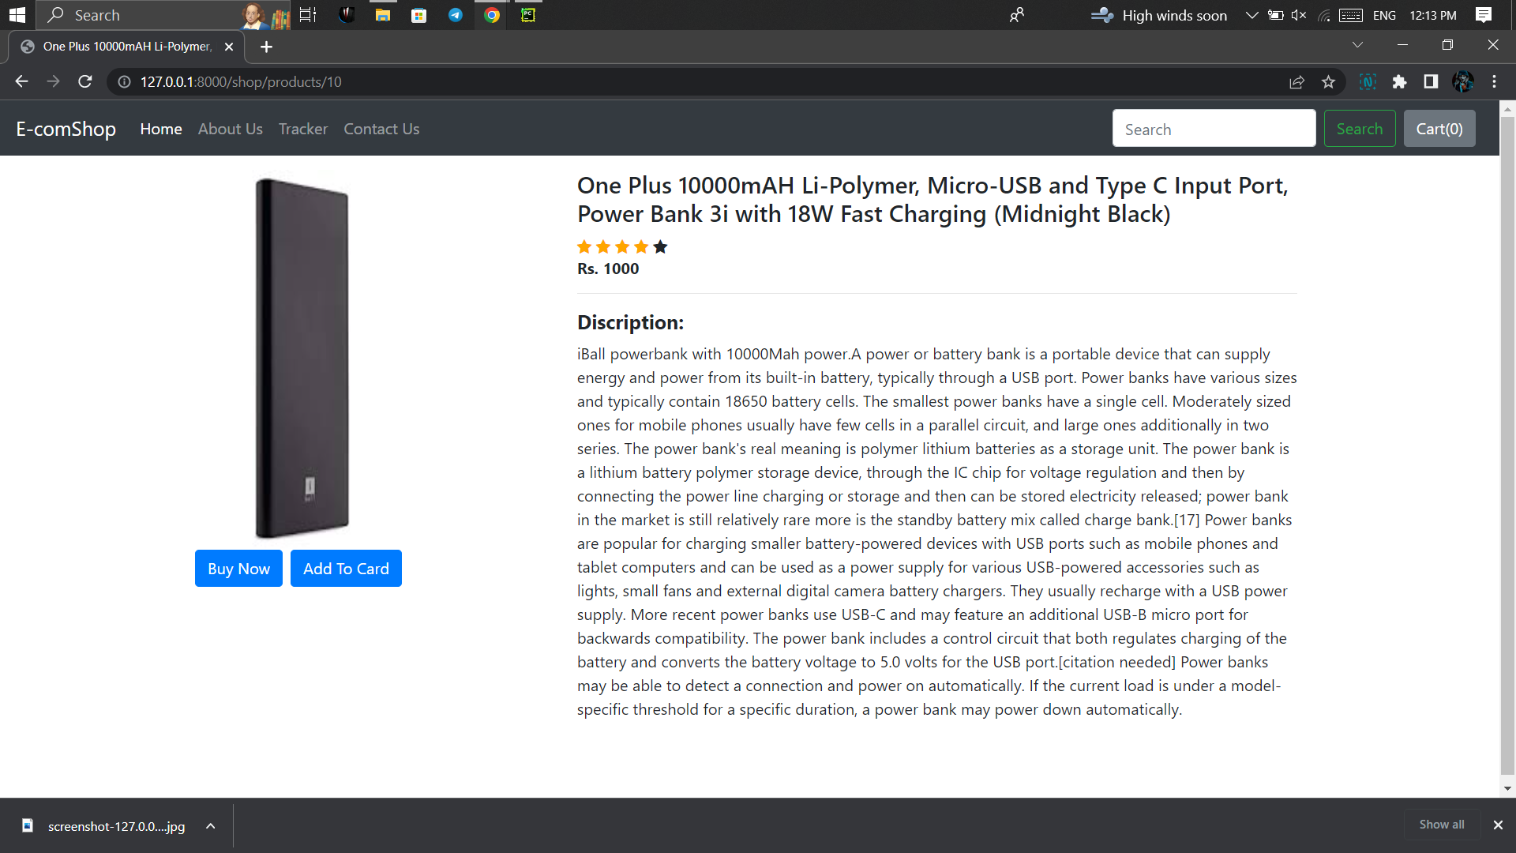

Search page: -

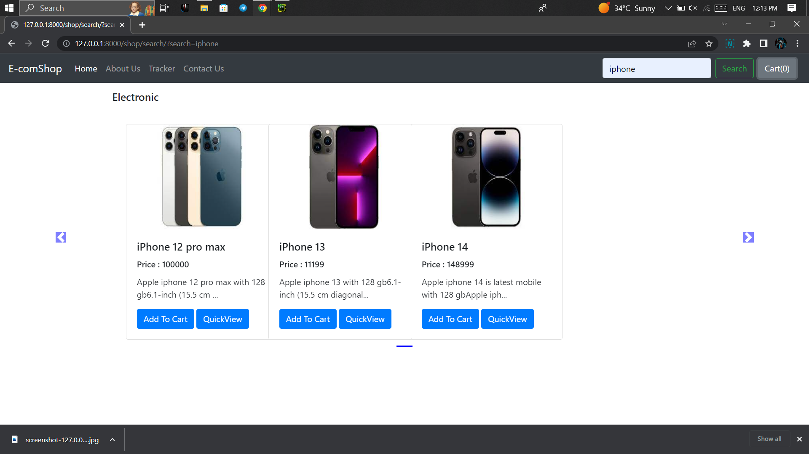

About us page: -

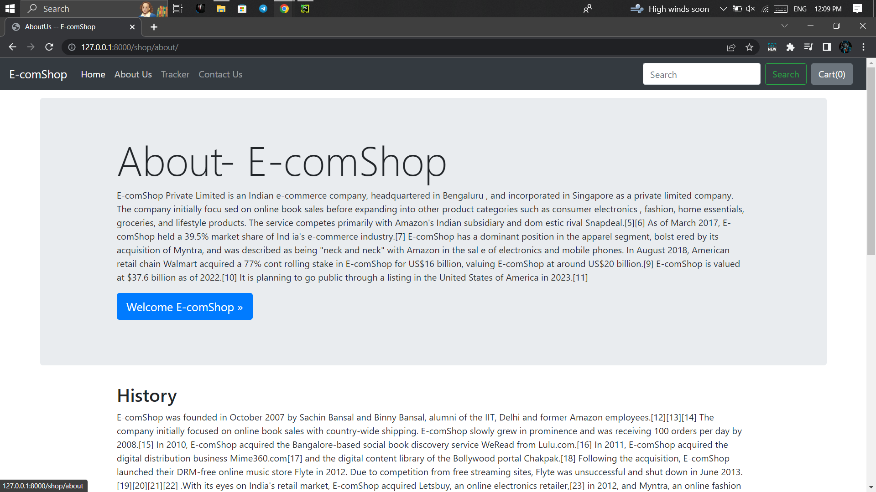

Order Tracker page: -

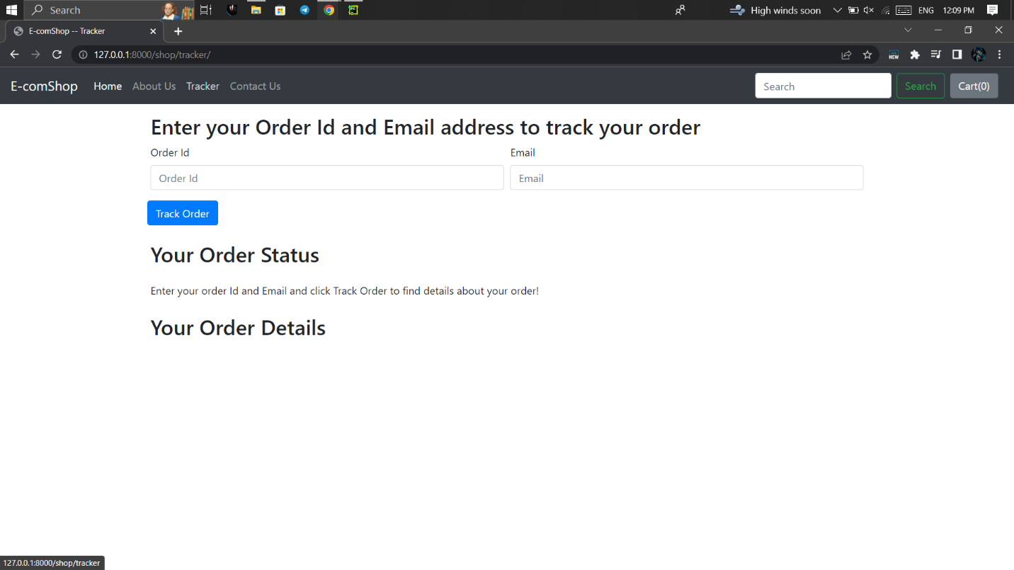

Contact us :-

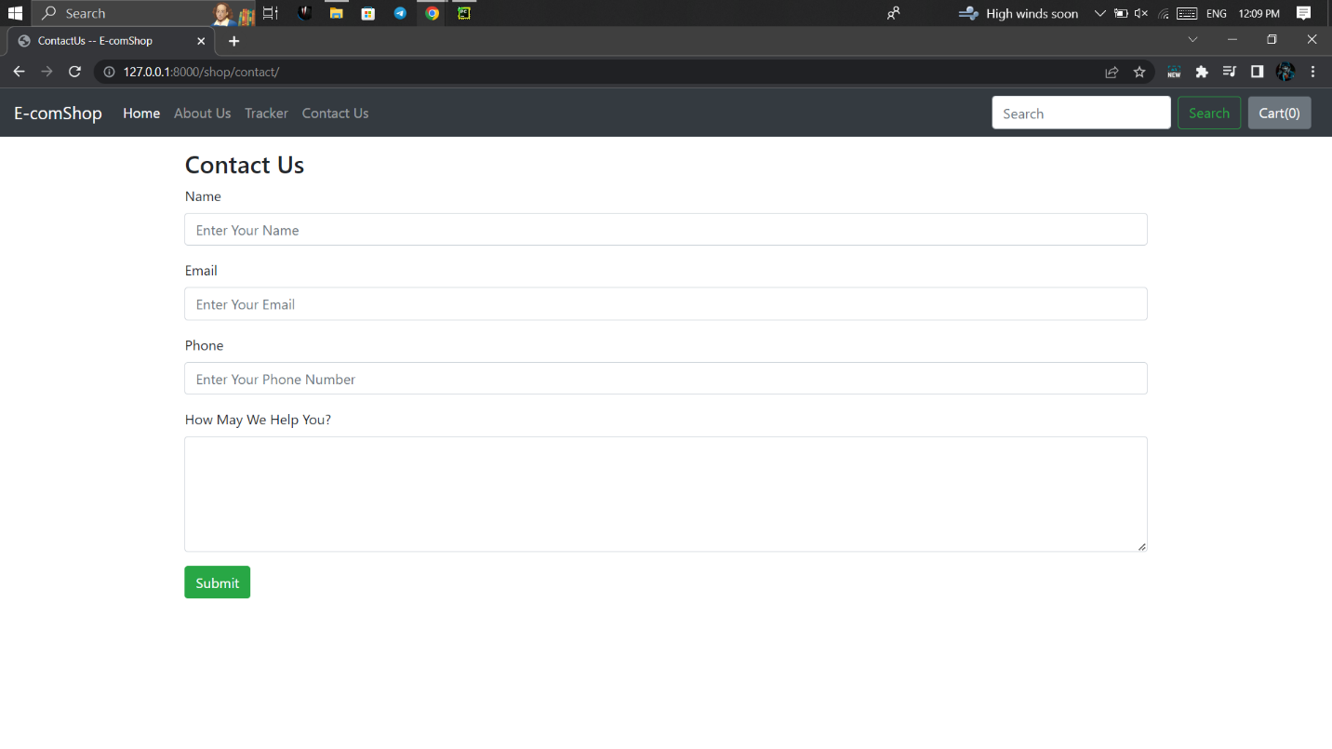

1. **Testing: -**

The purpose of testing is to discover errors. Testing is the process of trying to discover every conceivable fault or weakness in a work product. It provides a way to check the functionality of components, sub-assemblies, assemblies and/or a finished product It is the process of exercising software with the intent of ensuring that the Software system meets its requirements and user expectations and does not fail in an unacceptable manner. There are various types of test. Each test type addresses a specific testing requirement.

**TYPES OF TESTING**:

**Unit testing:**

Unit testing involves the design of test cases that validate that the internal program logic is functioning properly, and that program inputs produce valid outputs. All decision branches and internal code flow should be validated. It is the testing of individual software units of the application .it is done after the completion of an individual unit before integration. This is a structural testing, that relies on knowledge of its construction and is invasive. Unit tests perform basic tests at component level and test a specific business process, application, and/or system configuration. Unit tests ensure that each unique path of a business process performs accurately to the documented specifications and contains clearly defined inputs and expected results.

**Integration testing:**

Integration tests are designed to test integrated software components to determine if they actually run as one program. Testing is event driven and is more concerned with the basic outcome of screens or fields. Integration tests demonstrate that although the components were individually satisfaction, as shown by successfully unit testing, the combination of components is correct and consistent. Integration testing is specifically aimed at exposing the problems that arise from the combination of components.

## Functional test:

Functional tests provide systematic demonstrations that functions tested are available as specified by the business and technical requirements, system documentation, and user manuals.

Functional testing is centred on the following items:

Valid Input: identified classes of valid input must be accepted.

Invalid Input: identified classes of invalid input must be rejected.

Functions: identified functions must be exercised.

Output: identified classes of application outputs must be exercised.

Systems/Procedures: interfacing systems or procedures must be invoked.

Organization and preparation of functional tests is focused on requirements, key functions, or special test cases. In addition, systematic coverage pertaining to identify Business process flows; data fields, predefined processes, and successive processes must be considered for testing. Before functional testing is complete, additional tests are identified and the effective value of current tests is determined.

**System Test:**

System testing ensures that the entire integrated software system meets requirements. It tests a configuration to ensure known and predictable results. An example of system testing is the configuration-oriented system integration test. System testing is based on process descriptions and flows, emphasizing pre-driven process links and integration points.

**White Box Testing:**

White Box Testing is a testing in which in which the software tester has knowledge of the inner workings, structure and language of the software, or at least its purpose. It is purpose. It is used to test areas that cannot be reached from a black box level.

**Black Box Testing:**

Black Box Testing is testing the software without any knowledge of the inner workings, structure or language of the module being tested. Black box tests, as most other kinds of tests, must be written from a definitive source document, such as specification or requirements document, such as specification or requirements document. It is a testing in which the software under test is treated, as a black box .you cannot “see” into it. The test provides inputs and responds to outputs without considering how the software works.

**Unit Testing:**

Unit testing is usually conducted as part of a combined code and unit test phase of the software lifecycle, although it is not uncommon for coding and unit testing to be conducted as two distinct phases.

**Test strategy and approach:**

Field testing will be performed manually and functional tests will be written in detail.

**Test objectives:**

* All field entries must work properly.
* Pages must be activated from the identified link.
* The entry screen, messages and responses must not be delayed.

**Features to be tested:**

* Verify that the entries are of the correct format
* No duplicate entries should be allowed
* All links should take the user to the correct page.

**Integration Testing:**

Software integration testing is the incremental integration testing of two or more integrated software components on a single platform to produce failures caused by interface defects.

The task of the integration test is to check that components or software applications, e.g. components in a software system or – one step up – software applications at the company level – interact without error.

**Test Results:**

All the test cases mentioned above passed successfully. No defects encountered.

**Acceptance Testing:**

User Acceptance Testing is a critical phase of any project and requires significant participation by the end user. It also ensures that the system meets the functional requirements.

**Test Results:**

All the test cases mentioned above passed successfully. No defects encountered.

1. **Database discription: -**

An ecommerce website built with SQLite 3 database would typically include tables for storing information related to products, tracker, orders, and contact.

1. Product Table: This table would contain information related to the products being sold on the website, including the product name, category, subcategory, description, price, image, and published date.

2. order updates Table: This table would contain information related to customers, including their order id and update description.

3. Orders Table: This table would contain information related to customer orders, including the order details, amount , name , email, mobile, address, city, state , zip code.

4. Contact Table: This table would contain information related to customer who visit the website and send their feedback, including the user name, email, mobile, and feedback.

Overall, an ecommerce website built with SQLite 3 database would provide a reliable and efficient solution for managing product, customer, and order information, as well as payment transactions and other auxiliary data. It would be particularly suitable for small to medium-sized ecommerce websites with limited traffic and data volume.

1. **Conclusion and future scope :-**

**7.1 Conclusion :-**

In conclusion, ecommerce websites have revolutionized the way businesses sell products and services online, and they have become an essential tool for businesses of all sizes and industries. With the right hardware and software requirements, ecommerce websites can provide a seamless and secure shopping experience for customers, and help businesses reach a wider audience and increase sales.

**7.2 future scope :-**

The future scope of ecommerce websites is promising, with continued growth and evolution expected in the coming years. Some of the key areas of future development include:

1. Mobile commerce: With the increasing use of mobile devices for online shopping, ecommerce websites will need to be optimized for mobile devices to provide a better user experience.

2. Artificial intelligence and machine learning: Ecommerce websites can leverage AI and machine learning to personalize the shopping experience for customers, and to optimize inventory management and logistics.

3. Voice commerce: With the rise of smart speakers and voice assistants, ecommerce websites can leverage voice commerce to allow customers to make purchases using voice commands.

4. Augmented reality and virtual reality: Ecommerce websites can leverage AR and VR to provide customers with immersive shopping experiences, allowing them to virtually try on products and visualize them in their own spaces.

5. Blockchain technology: Blockchain technology can be used to enhance security and transparency in ecommerce transactions, ensuring that customer data and payment information are secure.

Overall, the future of ecommerce websites is bright, with continued innovation and development expected in the coming years. By staying up-to-date with the latest trends and technologies, businesses can leverage ecommerce websites to reach a wider audience, increase sales, and provide a better shopping experience for customers.